This is how I doing testing on my develop board and the screen

1. The screen is the develop board shell, so we can assemble them easily.

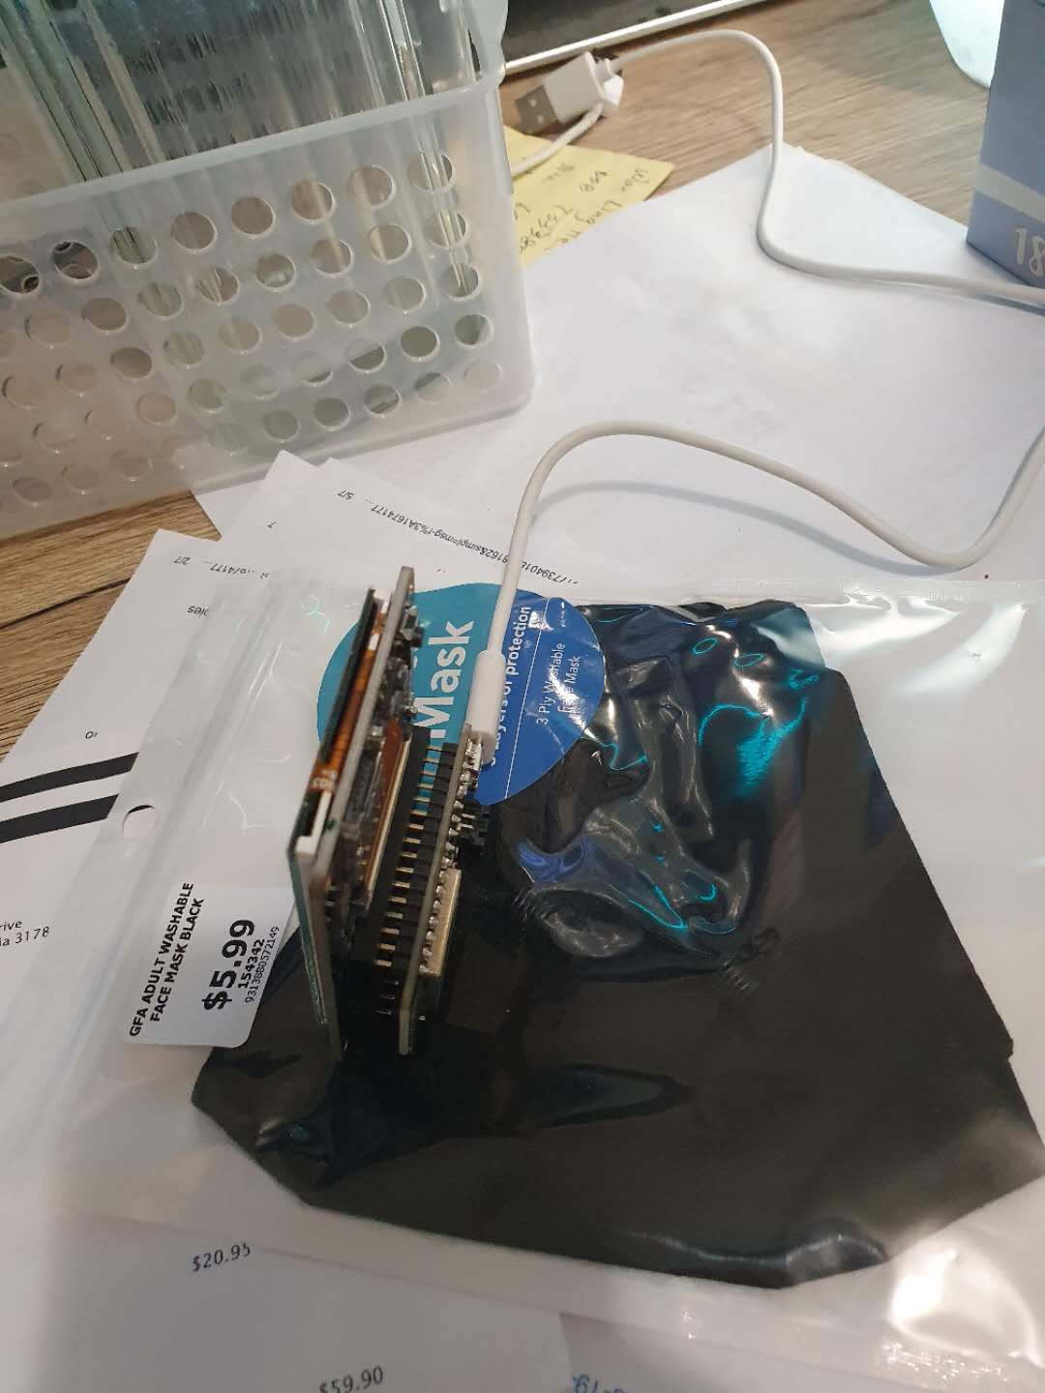

1. Then go to the find the Adafruit HUZZAH32 – ESP32 tutorial: (<https://learn.adafruit.com/adafruit-huzzah32-esp32-feather/using-with-arduino-ide>) install the USB driver and the hyper link((<https://github.com/espressif/arduino-esp32/blob/master/docs/arduino-ide/boards_manager.md>)) inside the page also have the tutorial about how to install the develop board.

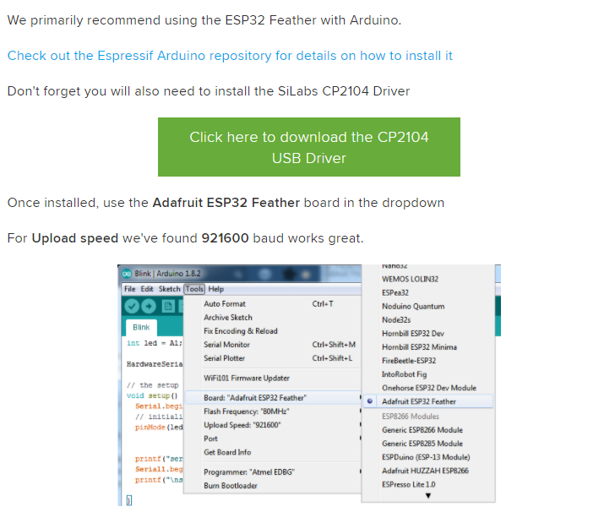

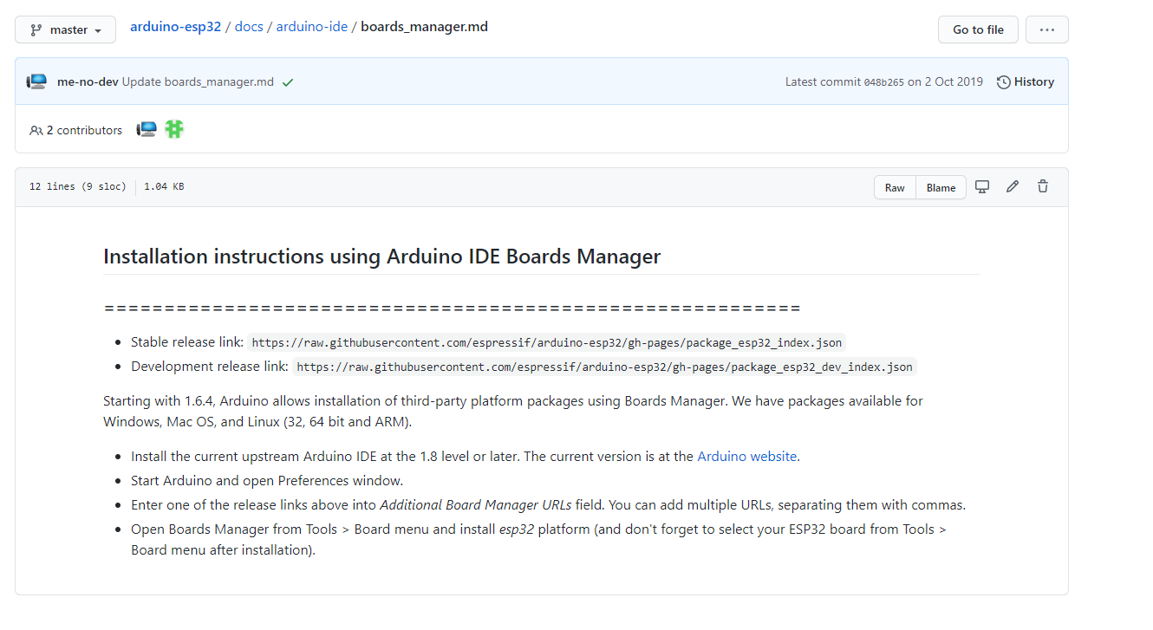

1. Now we will try to test the screen, go to Adafruit find the FeatherWIng: (<https://learn.adafruit.com/adafruit-2-4-tft-touch-screen-featherwing/tft-graphics-test>) follow the page Install all the library and doing test of the screen

